

LINUX BASH SCRIPTING LAB
(ENCS356)
Lab file Submitted to
K.R. MANGALAM UNIVERSITY
For
Bachelor Of Technology In
Computer Science Engineering with Specialization
In Cyber Security
Submitted By :
Setika Munjal (2301410029)
Faculty:
Dr. Rajesh Kumar

Experiment No. 1
Exploring Linux System Commands, Run Levels (Targets), and Help Utilities.
Problem Statement

Efficient use of the Linux operating system requires a strong understanding of basic system commands, system states, and built-in help mechanisms. Unlike graphical operating systems, Linux relies heavily on command-line utilities for system interaction, administration, and automation.
The problem is to explore and practice essential Linux system commands, understand system run levels / targets, and effectively use Linux help utilities such as man, --help, and auto- completion to access command documentation and usage information.

Aim
To study and execute basic Linux system commands, understand Linux run levels (systemd targets), and use Linux help utilities such as man, --help, and tab auto-completion.

Theory

Linux Command Line Interface (CLI)
The Linux Command Line Interface allows users to interact with the operating system by typing commands. It provides better control, flexibility, and efficiency compared to graphical interfaces, especially for system administration and automation.

System Run Levels / Targets
- Modern Linux systems use systemd, where traditional run levels are replaced by targets.
Common systemd targets:
- graphical.target – Multi-user mode with GUI
- multi-user.target – Multi-user mode without GUI
- rescue.target – Single-user rescue mode
- poweroff.target – Shutdown system
- reboot.target – Reboot system

Linux Help Utilities
Linux provides built-in help tools for learning commands:
- man – Displays complete manual pages
- --help – Shows brief command usage
- Tab auto-completion – Completes commands and file names automatically

Commands Used
Commands | Description
pwd | Display present working directory
ls | List files and directories
cd | Change directory
whoami | Display current user
date | Show system date and time
uptime | Show system running time
man | Display manual pages
--help | Display help for a command
systemctl | Manage system services and targets
runlevel | Display previous and current run level
clear | Clear terminal screen

Procedure / Steps

Step 1: Login:

Log in to the Linux virtual machine and open the Terminal.
Step 2: Execute Basic Linux Commands in the Terminal.
Commands:
- pwd shows current directory
- ls lists files
- whoami displays logged-in user
- date shows system date/time
- uptime shows how long system is running
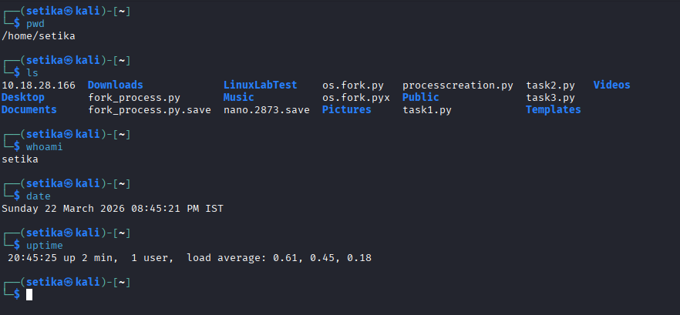

Step 3: Directory Navigation using:
- cd /home moves to home directory.
- cd ~ returns to user’s home directory.
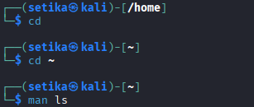

Step 4: Using Manual Pages
- man ls
- man cd
It Read command details.
  - Press q to exit the manual.
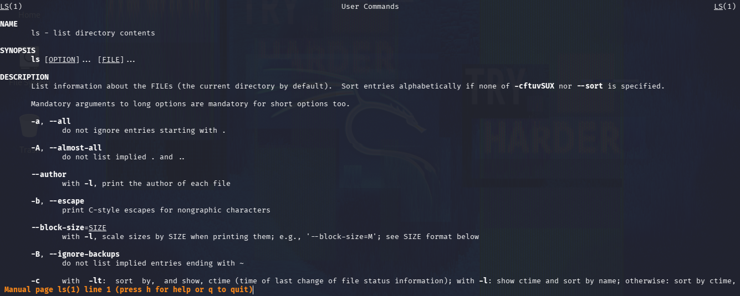
Step 5: Using Help Option:
- ls -–help
- systemctl -–help
This displays short usage instructions and options.
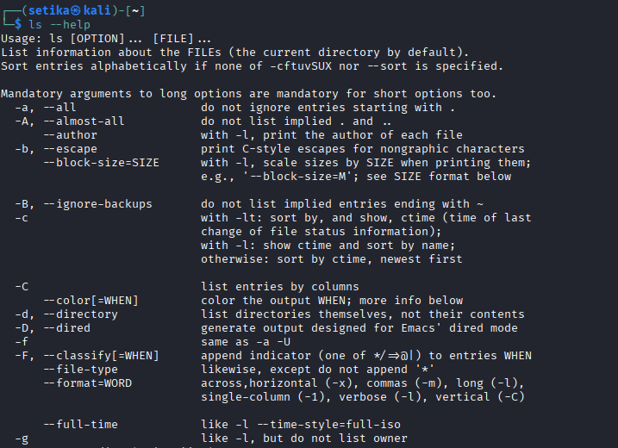
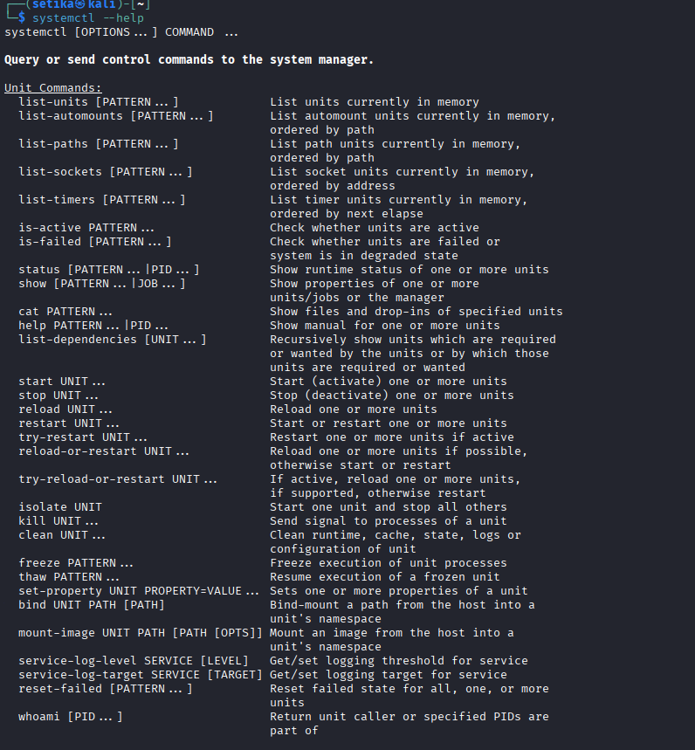

Step 6: Check System Run Level / Target
- runlevel- “Kali Linux uses systemd, so traditional runlevel commands are deprecated and systemctl targets are used instead.”
- systemctl get-default shows default system target.
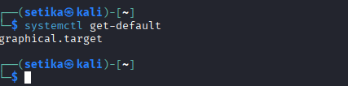

- Use clear command to clear the terminal.

Outcomes
- Successful execution of basic Linux commands
- Display of manual pages and help options
- Identification of current run level/target
- Improved command-line efficiency

Result
Thus, basic Linux system commands, system run levels, and help utilities were successfully explored. The student gained practical understanding of Linux command-line interaction and Linux documentation tools.

